Guide: Upgrade SelfHelp Project Version

This guide shows how to update a SelfHelp project to a new version, using the example of the "synesthesia" project on the VM becccs.psy.unibe.ch (130.92.252.61).

Console commands are **marked as quotes**.

# Systematic Guide:

First check and verify the current version of the project, usually on the project's Impressum page. You will usually need to be logged in as a user on the site:

<https://synesthesia.psy.unibe.ch/impressum>

Make sure that you have the credentials of a database user who has the necessary permissions on the project database to make changes and backups:

Log into the server and create a database backup (sql dump) of the project and save it.

becccs@becccs:~$ **mysqldump -u ns21f217 -p synesthesia > synesthesia_backup.sql**

The command “*mysqldump -u [database_username] –p [database_name] [tablename] > [database_backup_file]*” uses the flag ***–u*** for the database_username to connect to the MySQL server, then the ***–p*** flag to promt for the password of the database user. Then give the corresponding project *database name* (here: synesthesia) and the *file name* where the dump is stored.

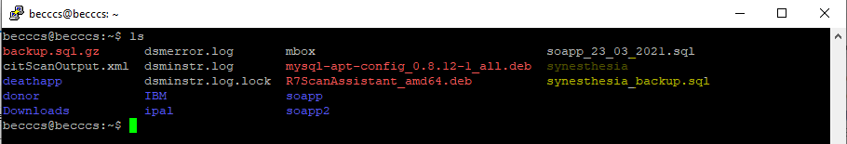

Check the PHP versions on the server and see which one is active. Newer versions of SelfHelp can use PHP8.

becccs@becccs:~$ **ls /usr/bin/php\***

becccs@becccs:~$ **php -v**

Next, when you are happy with the versions, go to the project folder:

becccs@becccs:~$ **cd synesthesia/**

becccs@becccs:~/synesthesia $

The first time the project is updated, the project folder must be configured as a safe folder so that we can retrieve the new versions:

becccs@becccs:~/synesthesia$ **sudo git config --global --add safe.directory /home/becccs/synesthesia**

Fetch the latest project versions, which are marked as tags:

becccs@becccs:~/synesthesia$ **sudo git fetch --tags**

Checkout the desired (latest) version, e.g. v5.11.0:

becccs@becccs:~/synesthesia$ **sudo git checkout tags/v5.11.0**

Go to the database folder inside the project folder:

becccs@becccs:~/synesthesia$ **cd server/db/update_scripts/**

becccs@becccs:~/synesthesia/server/db/update_scripts/$

[**ATTENTION 01**]

If the initial app/db version is lower than 4.9 or 5, the appropriate scripts in the db/archive folder must be run before the scripts in the “update_scripts” folder are run!

[**/ATTENTION 01**]

Run the SQL update scripts in the correct order and gradually. Ensure that the updates are incremental, starting from the original project and database version. If there are a lot of upgrade steps, the commands (the scripts) could also be linked so that not so many manual commands have to be entered:

becccs@becccs:~/synesthesia/server/db/update_scripts$ **mysql -u ns21f217 -p synesthesia < 12_update_v5.9.0_v5.10.0.sql**

becccs@becccs:~/synesthesia/server/db/update_scripts$ **mysql -u ns21f217 -p synesthesia < 13_update_v5.10.0_v5.11.0.sql**

**(…)**

[**ATTENTION 02**]

Especially when upgrading from an older SelfHelp version, the plugins used in the project will probably need to be reinstalled separately, as they have been removed from the base code repository. Run all plugin installation scripts systematically if there are more than one in the plugin. Example for Qualtrics:

becccs@becccs:~/synesthesia/server/plugins$ **sudo git clone http://tpf.fluido.as:10012/SLP/plugins/qualtrics.git qualtrics**

becccs@becccs:~/synesthesia/server/plugins$ **cd /qualtrics/server/db**

becccs@becccs:~/synesthesia/server/plugins/qualtrics/server/db $ **mysql -u ns21f217 -p synaesthesia < __installation_script_01.sql__**

[**/ATTENTION 02**]

[**ATTENTION 03**]

Enable the app to show version numbers on the imprint. To do this, change the ownership of some code files if you have not already done so.

becccs@becccs:~$ **sudo chown -R www-data:www-data /home/becccs/synesthesia/**

Do not forget that if a plugin is installed later, the ownership must also be adjusted for these code files.

[**/ATTENTION 03**]

On the Impressum page, check that the desired project, database and plugins version are displayed:

<https://synesthesia.psy.unibe.ch/impressum>

Scan the site with the Mozilla Scanner:

<https://observatory.mozilla.org/>

Write down the new project version and the changes in the file, internally e.g. under "IT Responsible/Server/" on the psy-nas or on the project overview in MS Teams.